**● Write SQL query to solve the problem given below**

CREATE TABLE Bank ( branch_id INT PRIMARY KEY, branch_name VARCHAR(50), branch_city VARCHAR(50) );

INSERT INTO Bank VALUES

(1, 'Main Branch', 'New York'),

(2, 'West Branch', 'San Francisco'),

(3, 'East Branch', 'Boston');

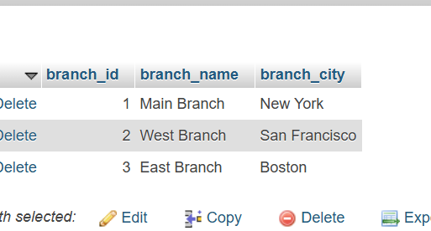

CREATE TABLE Account_Holder01 (

account_holder_id INT PRIMARY KEY,

account_no INT,

account_holder_name VARCHAR(100),

city VARCHAR(50),

contact VARCHAR(20),

date_of_account_created DATE,

account_status VARCHAR(20),

account_type VARCHAR(20),

balance DECIMAL(10, 2)

);

INSERT INTO account_holder01 VALUES

(1, 'A123', 'John Doe', 'New York', '123-456-7890', '2023-06-10', 'active', 'savings', 1000.00),

(2, 'B456', 'Jane Smith', 'New York', '234-567-8901', '2023-07-20', 'active', 'savings', 1500.00),

(3, 'C789', 'Sam Wilson', 'San Francisco', '345-678-9012', '2023-06-25', 'active', 'checking',1200.00);

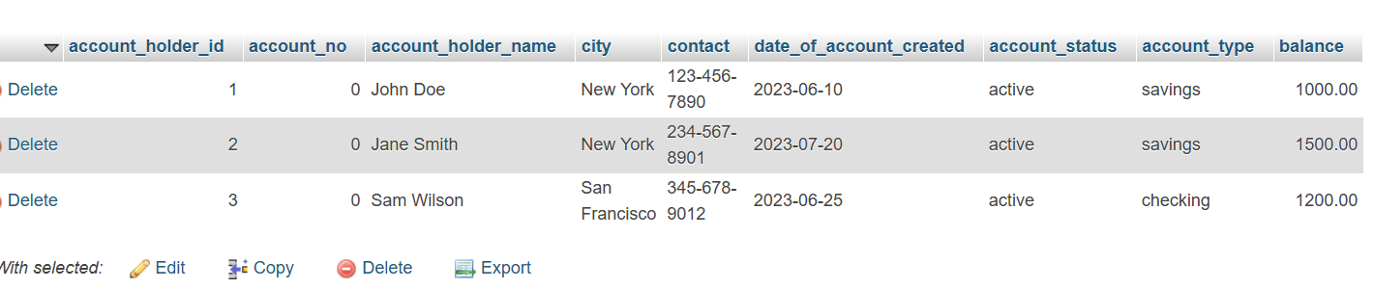

CREATE TABLE Loan ( loan_no INT PRIMARY KEY, branch_id INT, account_holder_id INT, loan_amount DECIMAL(10, 2), loan_type VARCHAR(50), FOREIGN KEY (branch_id) REFERENCES Bank(branch_id), FOREIGN KEY (account_holder_id) REFERENCES Account_Holder01(account_holder_id) );

INSERT INTO Loan VALUES (1001, 1, 1, 500.00, 'Personal Loan'), (1002, 2, 2, 1000.00, 'Home Loan');

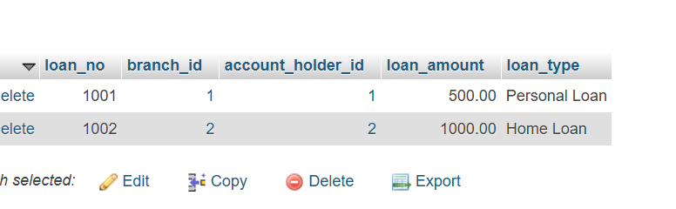

**1. Intra-Bank Transfer**

UPDATE account_holder01

SET balance = balance - 100

WHERE account_no = 'A123';

UPDATE account_holder01

SET balance = balance + 100

WHERE account_no = 'B456';

**2. Account Holders from the Same City**

SELECT * FROM Account_Holder01 WHERE city = 'New York';

**3. Accounts Created After 15th of Any Month**

SELECT account_no, account_holder_name FROM account_holder01

WHERE DAY(date_of_account_created) >= 15;

**4. City and Branch Count**

SELECT branch_city, COUNT(branch_id) AS Count_Branch

FROM Bank

GROUP BY branch_city;

**5. Account Holder Details and Loan Information**

SELECT account_holder_id, account_holder_name, branch_id,loan_amount

FROM Account_Holder01

JOIN Loan ON account_holder_id = account_holder_id

JOIN Bank ON branch_id = branch_id;